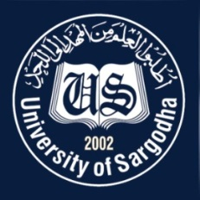 | Faculty Positions on Visiting Basis
 | Department of History and Pakistan Studies, University of Sargodha
Applications for the following positions are invited from Pakistani nationals for Spring Semester 2021.
Teaching Faculty

Sr.# | Positions | No. of Posts | Nature of Post | Eligibility Criteria
1. | Visiting Assistant Professor / Lecturers  1. History  2. Pakistan Studies | As per requirement | Visiting Faculty  (Open merit, for Spring semester 2021). | Qualification:  - Ph.D in relevant field for Assistant Professor  - MS / M. Phil in relevant field for Lecturer  Relevant Specializations:  PhD/M Phil/MS in any of these subjects  - History  - Historical Studies  - History and Civilization Studies  - Asian Studies  - South Asian Studies  - Pakistan Studies  - Political Science
NOTE |  |  | General Information
- As per university policy, the institute/department reserves the right not to consider any application or fill any post without giving any reason.
- Candidates are required to submit complete C.V and attested copies of testimonials along with
duly filled application form in the institute office.
- Prescribed application form may be downloaded from university website
(https://www.uos.edu.pk/adminForms)
- Applications complete in all respects should reach the institute on or before 18-02-2021.
- Interview of the short-listed candidates will be conducted on 19-02-2021 (at 10:00 am) in the office of Incharge, Department of History and Pakistan Studies, Sargodha University
- Only short listed candidates will be called for interview.
- The applicants having provisional transcript will not be eligible for the visiting faculty.
- Applications received after due date will not be entertained.
- Candidates with relevant experience will be preferred.
- Seats can be increased or decreased according to the requirement of subjects.
- Applications should be addressed to Incharge, Department of History and Pakistan Studies.
- Online applications will not be accepted.

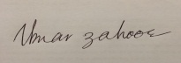
Incharge
Department of History and Pakistan Studies
University of Sargodha

